H1 Prelim 2
Structured Questions

1 | Iron(II) sulfate and ammonium sulfate combine to form the double salt iron(II) ammonium sulfate, FeSO₄.(NH₄)₂SO₄.xH₂O.  11.0 g of the double salt was dissolved in dilute sulfuric acid and made up to 250 cm³ mark in a standard flask. 25.0 cm³ of the solution required 28.00 cm³ of 0.02 mol dm⁻³ KMnO₄ for titration.
 | (a) | (i) | Write a balanced ionic equation for the reaction between Fe²⁺ and acidified MnO₄⁻.
 |  |  | 5Fe²⁺ + MnO₄⁻ + 8H⁺ → 5Fe³⁺ + Mn²⁺ + 4H₂O [1], without s.s
 |  | (ii) | Calculate the number of moles of MnO₄⁻ used in the titration.
 |  |  | [1]
No. of moles of MnO₄⁻ used in the titration = 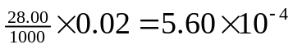
[]for working
[]for answer
 |  | (iii) | Calculate the number of moles of Fe²⁺ in 250 cm³ solution.  [2]
No. of moles of Fe²⁺ in 25.0 cm³ solution
= 5.60 x 10⁻⁴ x 5 [[]for ratio 5, ecf from (a)(i)]
= 2.80 x 10⁻³ []

No. of moles of Fe²⁺ in 250 cm³ solution
= 2.80 x 10⁻³ x 10 [[] for dilution factor 10]
= 2.80 x 10⁻² [[], ecf]

 |  | (iv) | Calculate the Mr of the double salt.
2.80 x 10⁻² × Mr = 11.0 [[], ecf]
Mr = 392.8 OR
≈ 393[[], ecf part (iii)]

 |  | (v) | Calculate the value of x.
[55.8 + 32.0 + 4(16.0) + 2(14 + 4) + 32 + 4(16) + x(18.0) = 393 [[], ecf]
x = 6 [[], ecf part (iii)]

 |  | [6]
 | (b) | Draw the Lewis structure of the NH₄⁺ and state its shape.  [2]
Shape of NH₄⁺:

[1] - include square bracket and –ve charge,
-do not penalise if dative bond is not shown / arrow is absent/pointing in wrong direction
- must be tetrahedral shape
Shape is tetrahedral. [1]
 | (c) |  | The reaction between zinc and copper(II) sulfate solution is exothermic and is represented by the following equation:  Zn(s) + CuSO₄(aq) → ZnSO₄(aq) + Cu(s)
 |  | (i) | Apart from a temperature rise, state two observations which could be made from the above reaction.
Red / brown / pink solid (Cu) forms [[] for colour; [] for Cu (solid)]
Blue solution fades/ become colourless [1]
Zinc dissolves [1]

Any two of the three above

 |  | (ii) | When excess zinc powder was added to a polystyrene cup containing 75.0 cm³ of aqueous copper(II) sulfate at 20.5 ºC, the temperature rose to 33.7 ºC. The copper metal formed was collected, washed, dried and found to weigh 0.42 g. Calculate the enthalpy change for this reaction in kJ per mole of copper formed.
Assume that the specific heat capacity and density of the solution is similar to that of water.

Energy released = mc∆T
= (75.0)(4.18)(33.7 – 20.5)
= 4138.2 J = 4.14 kJ [[] for working; [] ans]

No. of moles of Cu formed = 0.42 / 63.5
= 6.61 x 10⁻³ [[] for working; [] ans]

∆H per mole of copper = - 4.14 / 6.61 x 10⁻³
= -626 kJ [[] for working; [] ans, ecf from mc∆T]

 |  |  | [5]
 |  |  | [Total: 13]

2 | Acetic acid, CH₃COOH, also known as ethanoic acid, is an organic acid that gives vinegar its sour taste and pungent smell. It is a weak acid, in that it is only partially dissociated in an aqueous solution.
 | (a) | Write down the K_{a} expression for ethanoic acid.
 |  | [1]
 |  | K_{a} = 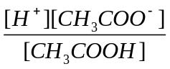 [1]
 | (b) | (i) | When a weak acid dissociates in aqueous solution, the concentration of H⁺ is given by the following expression.  [H⁺] =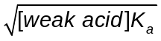  Given that the concentration of ethanoic acid is 0.720 mol dm⁻³ and its K_{a} is 1.8 x 10⁻⁵ mol dm⁻³. Calculate the concentration of H⁺ and pH of ethanoic acid.
[H⁺] = 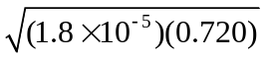 []correct substitution
= 3.60 x 10⁻³ []
pH = - log (3.60 x 10⁻³) []
= 2.44 []
 |  | (ii) | Suggest and explain the choice of an indicator for the titration of ethanoic acid and aqueous NaOH.
 |  |  | Phenolphthalein [1]. The equivalence point of a weak acid-strong base titration is more than 7 [], which falls in the working range of the indicator (8 - 10) [].
 |  | [5]
 | (c) | It is known that the relative molecular mass of ethanoic acid is 60. However, when ethanoic acid is dissolved in benzene, it is found that the relative molecular mass of the acid is 120. Explain this phenomenon using a clearly labeled diagram.  [3]
In benzene, two molecules of ethanoic acid combine together to form a dimer [award [1] if std write out the word or show the dimer in the diagram] through hydrogen bonding [award [1] if std write out the word or show the hydrogen bonding in the diagram].

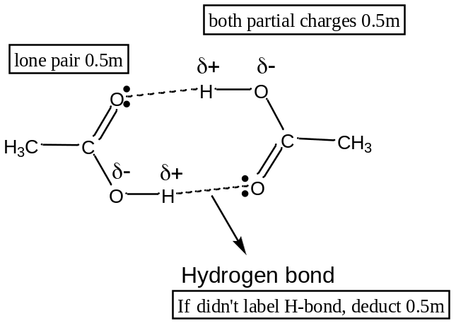
 |  |  | [Total: 8]

3 | Succinic acid, C₄H₆O₄ is a colourless crystalline solid with a melting point of 185 – 187 ºC. It occurs naturally in plant and animal tissues.
 | (a) | The scheme below shows how succinic acid, can be prepared from ethene.  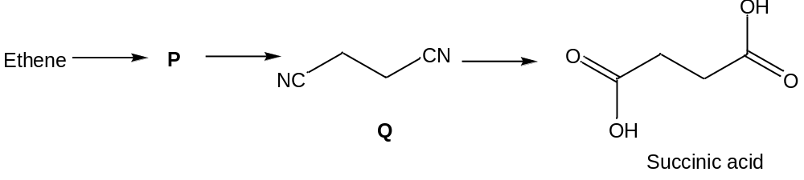
 |  | (i) | Draw the structure of compound P.
 |  |  | 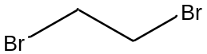 [1]
 |  | (ii) | Suggest how compound P can be prepared from ethene and name the type of reaction involved.
Reagent : Br₂ in CCl₄ OR Br₂(l) [1],
Condition : room temp (in the dark) [deduct []for heat]
(If std write Br₂(g) or Br₂(s), deduct [])

Type of reaction : Addition [1]
 |  | (iii) | Suggest how succinic acid can be synthesised from compound Q. State the type of reaction involved.
Reagent : Dilute HCl (or H₂SO₄) []
Condition : Heat with reflux []

Type of reaction : Acidic hydrolysis OR hydrolysis [1]
(if std write alkaline hydrolysis, deduct [])
 |  | (iv) | Draw the structural formula of the product formed when ethene reacts with steam and H₃PO₄ catalyst. State the functional group of the product formed.
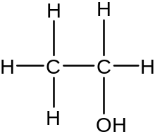[1]

Functional group : primary [] alcohol []
 |  |  | [7]
 | (b) | Describe a chemical test to distinguish between succinic acid and 2-hydoxy-3-methylbutanal.
 |  | 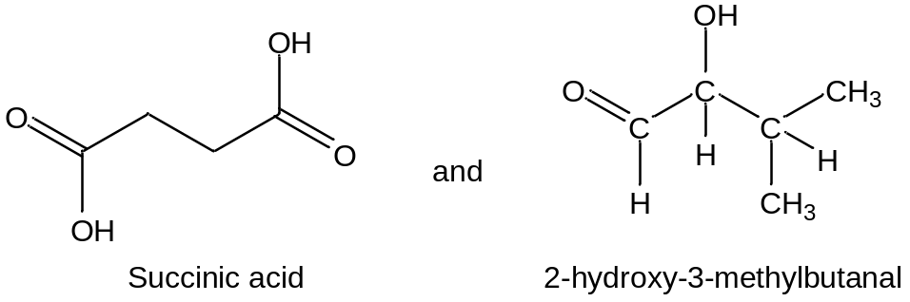
Reagent : Na₂CO₃ [1], room temp

Observation :
Succinic acid : Effervescence seen, gas forms white ppt with Ca(OH)₂ (aq) []
2-hydroxy-3-methylbutanal : No effervescence seen []

OR

Reagent : 2,4-dinitrophenylhydrazine [0.5], room temp []

Observation :
Succinic acid : No orange ppt []
2-hydroxy-3-methylbutanal : Orange ppt seen []

OR

Reagent : Tollen’s reagent [], warm []

Observation :
Succinic acid : No silver mirror []
2-hydroxy-3-methylbutanal : Silver mirror seen []

OR

Reagent : Fehling’s solution [], warm []

Observation :
Succinic acid : No brick red ppt []
2-hydroxy-3-methylbutanal : Brick red ppt [] and blue Cu²⁺ solution decolourised

OR

Reagent : KMnO₄ [], dilute H₂SO₄, heat with reflux []

Observation :
Succinic acid : Purple colour remains []
2-hydroxy-3-methylbutanal: Purple colour of KMnO₄ decolourised []

 |  |  | [2]
 |  |  | [Total: 9]

4 |  | (a) |  | Phenolphthalein is one of the most common indicators used to determine the end point in a titration. If excess base is present at the end of an acid-base titration, the pink colour fades if the solution is left to stand in air for a while.  The structure of phenolphthalein is abbreviated as ‘Y’.  The fading of phenolphthalein in aqueous NaOH (above pH 10) can be studied to determine its rate equation. The concentration of phenolphthalein in solution can be followed by a spectrophotometer, which measures the concentration of Y²⁻ in terms of “Absorbance”. [Y²⁻] is taken to be directly proportional to the absorbance of the solution.  Figure 4.1 shows the absorbance versus time graphs obtained for two different concentrations of NaOH, 0.200 mol dm⁻³ and 0.400 mol dm⁻³. In each case, only one drop of phenolphthalein was used.  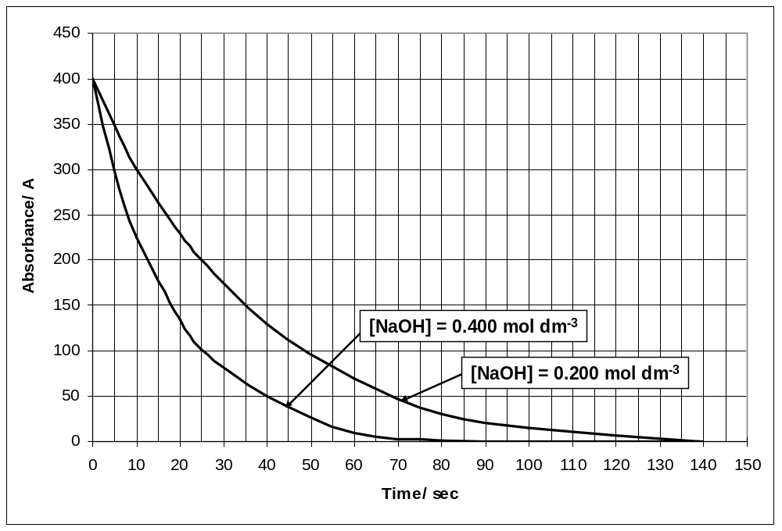  Figure 4.1
  pH | Form of phenolphthalein | Colour
  Below 8 | H₂Y | Colourless
  8 to 10 | H₂Y + OH⁻ Y²⁻ + H₂O | Pink
  Above 10 | Y²⁻ + OH⁻ YOH³⁻ | Colourless
 |  |  |  | Use the graphs to find the order of reaction with respect to
 |  |  |  | (i) |  | NaOH
Initial rate when [NaOH] = 0.200 mol dm⁻³
= 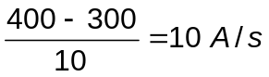 [] (units not marked for)
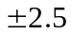value is accepted
Initial rate when [NaOH] = 0.400 mol dm⁻³
= 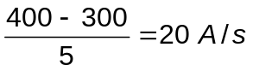 [] (units not marked for)
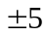value is accepted

For initial rates values that are outside the range, marks will not be given. However order of reaction can still be awarded.

When [NaOH] doubles, keeping [Y²⁻] constant, the rate also doubles. This implies that the order with respect to NaOH is 1. [1]
(if guess order correctly, [])
 |  |  |  | (ii) |  | Y²⁻
From Graph when [NaOH] = 0.200 mol dm⁻³
(show 2 sets of dotted lines to find half life - [])
The half-life of reaction is approximately constant at 25 sec [], hence order of reaction with respect to Y²⁻ is 1 [1]

OR

From Graph when [NaOH] = 0.400 mol dm⁻³
(show 2 sets of dotted lines to find half life - [])
The half-life of reaction is approximately constant at 12.5 sec [], hence order of reaction with respect to Y²⁻ is 1 [1]

 |  |  |  | (iii) |  | Hence, state the rate equation that describes the fading of phenolphthalein in aqueous NaOH above pH 10.
 |  |  |  |  |  | Rate = k [Y²⁻] [NaOH] [1]
 |  |  |  |  |  | [5]
 | (b) |  | Finland currently generates 55 % of its heat and energy from burning of fossils fuel which produces CO₂. This gives rise to increased CO₂ emission and poses environmental problems. However CO₂ can be removed by reacting with MgO to form MgCO₃.
 |  |  | (i) |  | MgO is formed from the thermal decomposition of MgSiO₃, a major component in mineral rocks. In this process, SiO₂ is also produced. Write a balanced equation for thermal decomposition of MgSiO₃.
 |  |  |  |  | MgSiO₃ → MgO + SiO₂ [1], don’t mark for state symbols
 |  |  | (ii) |  | During the thermal decomposition of mineral rocks, impurities like SO₂ are also produced. Arrange MgO, SO₂ and SiO₂ in the order of increasing acidity.
 |  |  |  |  | MgO, SiO₂ and SO₂ [1]
 |  |  | (iii) |  | Suggest a method how MgO can be separated from a mixture of MgO, SO₂, and SiO₂. Write balanced equations for the reactions involved.
Use concentrated NaOH [], both the other acidic oxides will be dissolved, leaving behind MgO/ filter the solution to obtain MgO as residue. []

SiO₂ + 2OH⁻ → SiO₃²⁻ + H₂O [1] , don’t mark for state symbols
SO₂ + 2OH⁻ → SO₃²⁻ + H₂O [1], don’t mark for state symbols

 |  |  |  |  | [5]
 |  |  |  |  | [Total: 10]

H1 Prelim 2
Essay Questions

5 | (a) | Ethyl acetate or ethyl ethanoate is the organic compound with the formula CH₃COOCH₂CH₃. This colorless liquid has a characteristic sweet smell (similar to pear drops) like certain glues or nail polish removers, in which it is used. Ethyl acetate is the ester of ethanol and acetic acid; it is manufactured on a large scale for use as a solvent. It is formed according to the equation below.  CH₃COOH (l) + CH₃CH₂OH (l) CH₃COOCH₂CH₃ (l) + H₂O (l)  In an experiment, 1 mol of ethanoic acid and 2 mol of ethanol were shaken for a long time to reach equilibrium. The whole mixture was titrated quickly with 2.00 mol dm⁻³ of sodium hydroxide and 80cm³ of alkali was required.
 |  | (i) | Calculate the number of moles of ethanoic acid present at equilibrium.
No. of moles of ethanoic acid present at equilibrium
= No. of moles of NaOH required

= 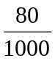x 2 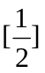 = 0.16

 |  | (ii) | Calculate the number of moles of ethanoic acid that had reacted with ethanol.
No. of moles of ethanoic acid reacted
= 1 – 0.16 = 0.84
 |  | (iii) | Calculate the number of moles of ethanol, ester and water present at equilibrium.
Number of moles of ethanol = 2-0.84 = 1.16
Number of moles of ester formed = 0.84
Number of moles of water formed = 0.84
OR combining answers (i) to (iii)

 | CH₃COOH (l) + CH₃CH₂OH (l) CH₃COOCH₂CH₃ (l) + H₂O (l)
Initial moles | 1 | 2 | 0 | 0
Change in moles | 1 – 0.16  = 0.84  Change  = -0.84 | -0.84 | +0.84 | +0.84
Eqm moles | x 2 = 0.16 | 1.16 | 0.84 | 0.84

 |  | (iv) | Write an expression of the equilibrium constant, K_{c} for this system.
 |  |  | 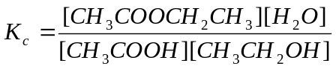 [1]
 |  | (v) | Calculate the value of the equilibrium constant, K_{c}.
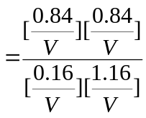
= 3.80 wrong units not penalised
 |  | (vi) | State the effect on K_{c} if 0.1 mol of ethanol liquid was introduced into the container after equilibrium has been established.
 |  |  | No effect on K_{c} [1] as it is only affected by temperature.
 |  |  | [7]
 | (b) | Acetic acid, CH₃COOH, also known as ethanoic acid, is an organic acid that gives vinegar its sour taste and pungent smell. It is a weak acid, in that it is only a partially dissociated acid in an aqueous solution
 |  | (i) | Suggest the reagents and conditions for the conversion of ethanoic acid into an alcohol.
Reagents: Lithium aluminium hydride, LiAlH₄
Conditions: in dry ether
 |  | (ii) | Name the type of reaction that occurs and write a balanced equation for the conversion of ethanoic acid into an alcohol.
Type of reaction: Reduction [1]

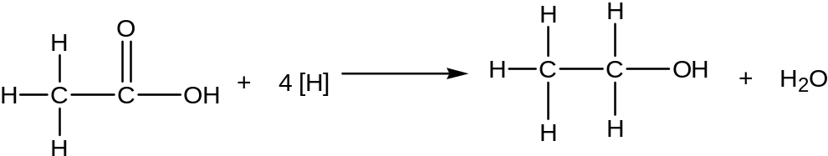
[1]

 |  | (iii) | Describe what you would observe when ethanoic acid was reacted with sodium metal.
Effervescence observed. [1]

Gas evolved will extinguish lighted splint with a ‘pop’ sound. [0.5] [Award this mark only if std didn’t mention effervescence.]

 |  |  | [4]
 | (c) | Period 3 chlorides have many uses.  Phosphorus trichloride, PCl₃ is an essential precursor to PCl₅, POCl₃ and PSCl₃. which in turn have many applications in herbicides, insecticides, plasticisers, oil additives and flame retardants.  Silicon tetrachloride, SiCl₄ is sometimes used as an intermediate in the manufacture of extremely pure silicon.
 |  | (i) | Describe and explain what you would observe when water is gradually added to PCl₃, until in excess. Suggest the pH of the solution.
 |  |  | Phosphorus (III) chloride undergoes hydrolysis [1] with water, to produce steamy HCl fumes and phosphonic acid, H₃PO₃. The solution has a pH = 2 [1]
 |  | (ii) | Suggest a balanced equation with state symbols for the reaction of liquid silicon tetrachloride with heavy water, D₂O. [deuterium, D= 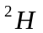]
SiCl₄(l) + 2D₂O(l) 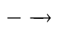 SiO₂(s) + 4DCl(aq) [1]
Or SiCl₄(l) + 4D₂O(l) Si(OD)₄(s) + 4DCl (aq)
 |  |  | [4]
Atomic No.  K  Atomic No.  First Ionisation Energy  x x+1 x+2 x+3 x+4  First Ionisation Energy  x-8 x x+8  J  L  M  N  J | (d) | The graphs below show the variation in first ionisation energy of some elements. Figure 5.1 refers to elements in the same period, and Figure 5.2 refers to elements in the same group as element J.  Figure 5.1 Figure 5.2
 |  | (i) | Element J is a Group II element. Recopy the diagram below and label clearly how the beams of J⁺ and K⁺ ions are deflected when subjected to an electric field.  You should relate clearly the magnitude and the direction of deflection of each beam to the other.  +  -  [3
J: Group II element
K: Group III element

Deflection 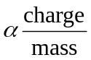
Mass of K⁺ > mass of J⁺
Angle of deflection for of J⁺ > Angle of deflection for of K⁺
NOTE: mark given for working or shown in diagram

+
-
J⁺
or [1]
K⁺
or [1]
Source

If no working is given, [1] can be awarded for J⁺ and K⁺

 |  | (ii) | State and explain which period element J is in and hence identify J.
Based on Figure 5.2, J is in period 3. [1]

Only in period 2-4, atomic number have a difference of 8 down the group.

From period 5, the increase in atomic number down the group is 18.

J is Magnesium [1]

 |  |  | [5]
 |  |  | [Total: 20]

6 | Compound A, a derivative of Decalin is a colorless liquid. It can undergo the following 3-step reaction scheme.  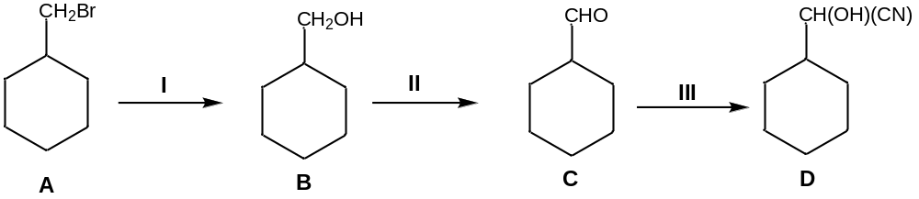
 | (a) | (i) | What reagents and conditions are needed for reactions I, II and III?
Reaction I: NaOH/KOH (aq) [1/2] reflux [1/2]

Reaction II: K₂Cr₂O₇ [1/2] dilute H₂SO₄, distill [1/2]

Reaction II: HCN [1/2] trace amount of NaOH/NaCN, 10-20°C [1/2]
 |  | (ii) | Name the type of reaction for reaction III.
 |  |  | Addition [1]
 |  | (iii) | Reaction II is an oxidation reaction. Write a balanced equation for reaction II.  (The symbol [O] is acceptable in this equation.)
 |  |  | 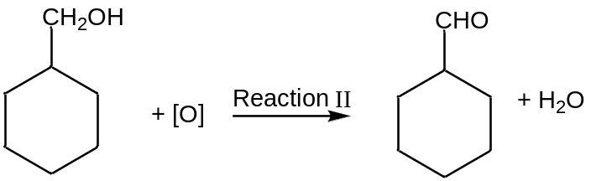 [1]
 |  |  | [5]
 | (b) | Draw the organic product formed when B is reacted separately with each of the reagents and conditions stated below.
 |  | (i) | Al₂O₃, 350°C
 |  |  | 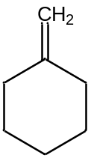 [1]
 |  | (ii) | PCl₅
 |  |  | 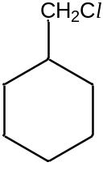 [1]
 |  |  | [2]
 | (c) | (i) | Compound A, C₇H₁₃Br has a structural isomer with a straight chain and displays geometric isomerism. Suggest a possible structure of the isomer.
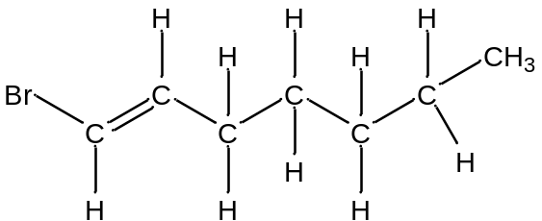 [1]

any variation of C₇H₁₃Br and must have cis-trans
 |  | (ii) | Suggest a chemical test to distinguish A and the isomer identified in (c)(i). You should include suitable observations for the test.
Reagent: Br₂ (aq) [1]
Condition: Room temperature (penalise [1/2] for heat)
Observation:
Structural isomer: Orange Br₂(aq) will decolourise [1/2]
Compound A: Orange Br₂(aq) will not decolourise [1/2]

OR

Reagent: Liquid Br₂ [1]
Condition: Room temperature (penalise [1/2] for heat)
Observation:
Structural isomer: Reddish brown Br₂ will decolourise [1/2]
Compound A: Reddish brown Br₂ will not decolourise [1/2]

OR

Reagent: KMnO₄ [1/2]
Condition: dilute H₂SO₄, reflux [1/2]
Observation:
Structural isomer: Purple KMnO₄ will decolourise [1/2]
Compound A: Purple KMnO₄ will not decolourise [1/2]

Ecf for test if compound for c(i) drawn wrongly but c(i) must have double bond.
 |  | [3]
 | (d) | D with molecular formula C₉H₈O is used as a drug carrier. D is insoluble in sodium hydroxide but reacts with 1 mole of bromine gas in the dark to form E, C₉H₈OBr₂.  When E is heated with aqueous potassium hydroxide, F, C₉H₁₀O₃, a neutral compound is formed.  Treatment of D with Tollens’ reagent will yield silver mirror but when treated with Fehling’s solution, blue colour solution remains. When D is heated with acidified potassium manganate (VII), G, C₈H₆O₄ is formed. G will produce effervescence when Na₂CO₃ is added to it.  Use all of the above information to identify the organic compounds D, E, F, and G. Include the following in your answers
 |  | (i) | Structural formula for each of the organic compounds.
 |  | (ii) | Clearly show all of the deductions that you make from the information that you have been given.
There is comparable number of C and H in compound D, hence, Compound D contains a benzene ring. [1]
Compound D is most likely an alcohol. [1] since it is insoluble in sodium hydroxide
It reacts with bromine gas in the dark, hence an alkene is present. [1]. It reacts in addition reaction. [1]
Compound E reacts with aqueous potassium hydroxide in substitution reaction. [1]
It contains alcohol group as the compound is neutral. [1]
It reacts with Tollen’s reagent but not Fehling’s solution, hence it contains aromatic aldehyde. [1]
When reacted with potassium manganate (VII), oxidation takes place. [1]
Compound G reacts with Na₂CO₃ via acid-carbonate [1] reaction as it contains carboxylic acid. [1]The effervescence is due to CO_{2.} [1]

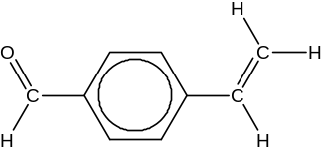Compound D [1],
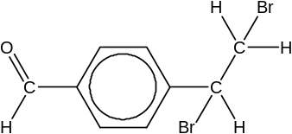Compound E [1],
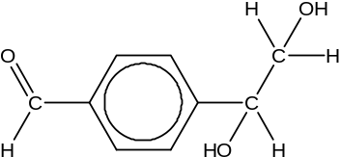Compound F [1],
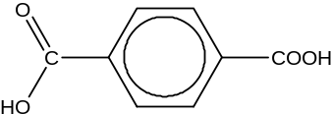Compound G [1]
10 max out of 15
Accept 1, 2 position and 1,3 position.
 |  | [10]
 |  | [Total:20]

7 | Chromium is a very shiny, silvery metal whose Greek name, Chroma, refers to its many colourful compounds.
 | (a) | In air, chromium readily forms a thin and transparent coating of Cr₂O₃. Like Al₂O₃, Cr₂O₃ is an amphoteric oxide and can react with both acids and bases.
 |  | (i) | Suggest a reason why chromium is used extensively as a coating for other metals like iron.
 |  |  | Chromium forms an inert oxide layer [], will protect the metal from corrosion [].
 |  | (ii) | Write 2 balanced equations with state symbols that shows the amphoteric nature of Cr₂O₃.
Cr₂O₃ (s) + 6H⁺ (aq) → 2Cr³⁺ (aq) + 3H₂O (l) [1]
Cr₂O₃ (s) + 3H₂O (l) + 2OH⁻ (aq) → 2 Cr(OH)₄⁻ (aq) [1]

 | (b) | Chromium can also exist in the form of chromate, CrO₄²⁻, which can be prepared from chromium(III) chloride. This conversion takes place in the presence of hydrogen peroxide, H₂O₂.
 |  | (i) | Write the half equation for the conversion of H₂O₂ to OH⁻ in alkaline medium.
 |  |  | H₂O₂ (l) + 2e⁻ → 2OH⁻ (aq) [1] (state symbols not marked for)
 |  | (ii) | Given that the half equation for the conversion of Cr³⁺ to CrO₄²⁻ in alkaline medium is as shown below.  Cr³⁺(aq) + 8OH⁻(aq) CrO₄²⁻(aq) + 4H₂O(l) + 3e⁻  Using your answer to b(i), write the overall balanced equation of the conversion of Cr³⁺ to CrO₄²⁻ in the presence of H₂O₂ in alkaline medium.
2Cr³⁺ (aq) + 10 OH⁻ (aq) + 3H₂O₂ (l) → 2CrO₄²⁻ (aq) + 8H₂O (l) [1]
(state symbols not marked for)
 |  | (iii) | Hence calculate the minimum volume of 0.200 mol dm⁻³ H₂O₂ required to convert a sample of 0.500 g of CrCl₃ completely to CrO₄²⁻.
No. of moles of CrCl₃ = 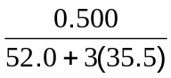[] = 0.00315 mol []
No. of moles of H₂O₂ required = 3/2 x 3.15 x 10⁻³ [] = 4.73 x 10⁻³ mol []
“3/2” ecf from equation in part iv)

Volume = 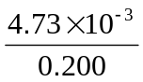 [] =0.0237 dm³ []
 |  |  | [8]
 | (c) | Draw the dot-and-cross diagram of H₂O₂ and state its shape.
[1]
Shape: Bent [1]
 |  | [2]
 | (d) | Besides chromium (III) chloride, chlorides of Period 3 elements are also well-studied. State and explain the electrical conductivity of the chlorides of magnesium and phosphorous in both molten and aqueous states.
Chlorides of magnesium can conduct electricity [] in molten and aqueous states, while chlorides of P cannot [].
MgCl₂ is has giant ionic structure. In the molten and aqueous states, there are mobile charge carriers (ions) [1], hence able to conduct electricity.
PCl₃ or PCl₅ has a simple molecular structure. In both molten and aqueous states, there no mobile charge carriers [1] (if std write no mobile ions [0.5]), hence unable to conduct electricity.
 |  | [3]
 | (e) | When chromium (III) chloride is dissolved in water and aqueous ammonia is subsequently added in excess, the compound [Cr(NH₃)₆]³⁺ is formed. The following diagram shows how the NH₃ molecules are arranged around the central Cr³⁺ ion.  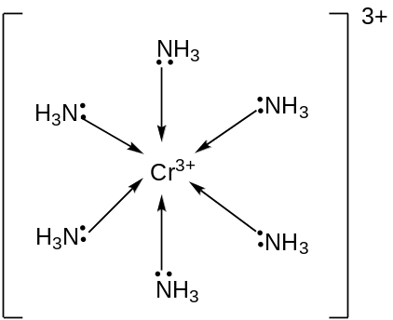  The arrow denotes a dative bond from the N atom to Cr³⁺, as shown below:  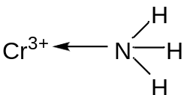
 |  | Using the Valence Shell Electron Pair Repulsion (VSEPR) Theory, explain the phenomenon that the H-N-H bond angle in ammonia when it is bound to Cr³⁺ is about 110 º, while that in an isolated ammonia molecule is about 107 º.
In the complex [Cr(NH₃)₆]³⁺, the N atom in NH₃ is dative-bond to Co³⁺ ion.
Hence, there are 4 bond pairs and zero lone pairs on N atom [1]. [If std did not indicate N atom, deduct 0.5m. If std write Cr atom, 0m]

To minimize repulsion, electron pairs are directed to the 4 corners of a tetrahedron [ ], hence bond angle is about 109.5 º (about 110 º). In an isolated ammonia molecule, there are 3 bond pairs and 1 lone pair [1]. Since lone pair-bond pair repulsion is larger than bond pair-bond pair repulsion [], the bond angle is compressed to 107 º.

Max 2 out of 3 marks

 |  | [2]
 | (f) | In another compound containing boron chloride and phosphine, an equilbrium exists between the compound, PH₃BCl₃, and its adducts PH₃ and BCl₃ as shown.  PH₃BCl₃ (s) PH₃ (g) + BCl₃ (g) ∆H > 0
 |  | (i) | Write an expression for the equilibrium constant, K_{c}, for the decomposition of PH₃BCl₃ (s).
 |  |  | K_{c} = [PH₃][BCl₃] [1]
 |  | (ii) | A solid sample of PH₃BCl₃ is introduced in a closed vessel and decomposes until equilibrium is established. Explain how the equilibrium position will be affected when the
- temperature is increased to 373 K.
- solid PH₃BCl₃ is added to the system at equilibrium
- When temperature is increased, by Le Chatelier’s Principle, equilibrium position shifts to the right [1] to favour the endothermic reaction [0.5] to absorb additional heat [0.5].

- Equilibrium position is unaffected [1]as the addition of solid does not affect the concentration of PH₃ and BCl₃ OR the concentration of solid is constant OR total pressure remains unchanged [1].

 |  |  | [5]
 |  |  | [Total: 20]

